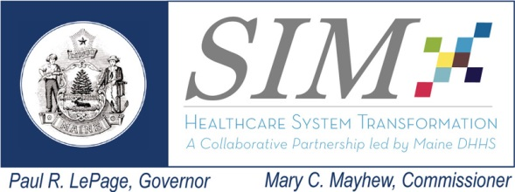
Subcommittee: Payment Reform
Date: October 21, 2014
Time: 3:00 to 5:00 pm
Location: MaineGeneral Medical Center

Chair Frank Johnson
Core Member Attendance: Patrick Denning, Harvard Pilgrim Health Car (remote); Bob Downs, Aetna (remote); Chrissi Harding, Mount Desert Hospital (remote); Peter Kraut, MaineCare; Dr. Jamie Kuhn, Maine Orthopedics (remote); Michelle Probert, BIW; Cheryl Rust, Consumer.

Interested Parties & Guests: Dr. Barbara Crowley, MaineGeneral; David Winslow, Maine Hospital Association; Katie Fullam Harris, MaineHealth; Deb Wigand, Maine CDC; Barbara Ginley, Maine CDC; Bob Howe, Howe and Cahill; Barbara Leonard, MeHAF; Andy Webber, MHMC; Marie Stukey, MHMC (remote).

Staff: Lisa Nolan, MHMC; Patti Ross, MHMC

Topics | Lead | Notes | Actions/Decisions
- Progress Report on Behavioral Health PTE measures | Patti Ross | Patti Ross updated the Subcommittee on the current work of the PTE (Pathways to Excellence) Behavioral Health initiative. The BH PTE group has solicited initial public reporting from approximately 1,600 outpatient BH providers with the intent to begin public reporting in January 2015.The initial reporting will be predicated on the attestation of three domains identified by the work group. Patti outlined the work group’s composition and objectives for expanding public reporting | DNA
- Discussion on Risk Statement # 21 | Frank Johnson | Frank briefed the Subcommittee on Risk # 21 as identified by the Delivery System Subcommittee. Frank presented a proposal which includes the findings of the alternative payment inventory in the commercial sector, querying the health systems and payers on the pace of transition from fee-for-service to capitation, recommend interim steps that support non-duplicative care coordination payments with the intent to to sustain care coordination reimbursement. | MHMC will proceed with proposal and report back to the Subcommittee.
- Community Health Worker Initiative | Deb Wigand and Barbara Ginley | Deb and Barbara provided background on the development of the Community Health Worker (CHW) initiative, the stakeholder group guiding the project, the four pilots that have been selected, and the initiative’s identified milestones. Deb and Barbara also solicited the Subcommittee’s ideas on how to support CHW in terms of embedding in the delivery system and facilitating reimbursement. | DNA
- Cost of Care Work Group and CEO Summit | Lisa Nolan | Lisa briefed the Subcommittee on the recent developments of the Work Group including the recommendation to adopt a voluntary annual growth cap on risk-based contracts. Lisa reviewed the various options considered by the Work Group and the proposal to the CEO Summit which calls for a voluntary growth cap beginning at the medical CPI in 2015 and incrementally adjusting to 25% above the urban CPI minus energy and food. Lisa reported that nearly half of the purchasers have responded to a survey to determine their support. The responses have been overwhelmingly favorable. | DNA
- Upcoming Activities | Frank Johnson | Frank reported that the ACI Committee will be focusing attention on examining primary care payment reform and the Subcommittee will be invited to the next two ACI meetings to engage in this dialogue. | DNA
- Interested Parties Public Comment | All | There was no public comment. | DNA
Next Meeting |  | To be determined.

Next Meeting:
December 16, 2014

Workgroup Risks Tracking
Date | Risk Definition | Mitigation Options | Pros/Cons | Assigned To

Dependencies Tracking
Payment Reform | Data Infrastructure | Delivery System Reform | Other

